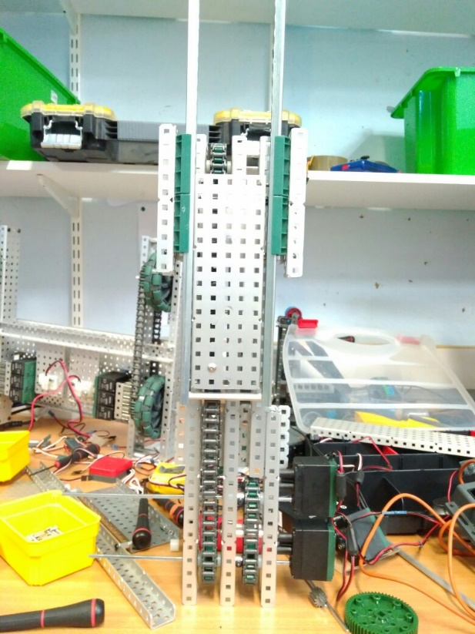

By Robbie Buxton

5/7/2017 – 15:49

**Overview:**

For this version of the robot we have remade the first prototype version of the lift. It is now held together with nylons meaning it is far stronger. We have also added a second stage to the lift. The second stage is held in the mount on the first stage and is fastened to the chain allowing it to move up and down in the y axis. To make the third stage of the lift we need two 12 tooth sprockets so for the time being until we get them we have to keep it two stages. We also tested the strength of the lift using a newton meter finding it could lift up to 3kg. this means that when we add two more motors it should be able to lift upwards of 6kg. The crucial factor is whether or not the chain inside the lift could support the weight. The tensile strength provided on the website states that the chains is approximately 22.5 kg so we should be fine. We will test this anyway.

**What needs to be changed:**

* Add a third stage
* Add two more motors
* Attach to robot

**WHAT HAS BEEN CHANGED:**

* Remade the first stage with nylocs
* Added mount for second stage
* Attached second stage

SPECIFICATIONS:

* 6 Motor HS drive
* Two drive chains
* 4 wheels
* Aluminium structure
* 2 motor lift
* Two stage lift

DIMENTIONS:

17.5” * 15” * 17.5

Robot V 1.14